**PROJECT REPORT**

**on**

**Random Password Generator**

**(CSE - IV Semester Mini project)**

**2021-2022**



**Submitted By :-**

**Name – RISHAV KUMAR**

**University Roll No – 2018637**

**Semester – IV**

**Section - D**

**DEPARTMENT OF COMPUTER SCIENCE AND INFORMATION TECHNOLOGY**

**GRAPHIC ERA HILL UNVERSITY, DEHRADUN**

**CERTIFICATE**

### Certified that Mr. Rishav kumar(Roll No. 2018637) have Completed Semester IV Mini Project “Random Password Generator” in Graphic Era Hill University, Dehradun. The student has Created the Project to the best of my knowledge.

**ACKNOWLEDGMENT**

We wish to thank our parents for their continuing support and encouragement. We also wish to thank them for providing us with the opportunity to reach this far in our studies.

We are greatly indebted to all other persons who directly or indirectly helped us during this work.

Mr. Rishav kumar

Roll No.- 2018637

CSE-D-IV-Sem

Session: 2021-2022

GEHU, Dehradun

Table Of Content

1. Introduction
   1. Introduction To Random Password Generator
   2. Use Of Random Password Generator
   3. About The Project
   4. About The Modules and Libraries And There Use In Project
      1. About String Module In Project
      2. About Random Module In Project
      3. About Time Module In Project
      4. About os Module In Project
      5. About Base64 Module In Project
      6. About Tkinter Library In Project
      7. About Pyperclip Library In Project

1.5 .py To .exe

1. Project
   1. Generating Random Password (with Code)
   2. GUI
      1. Code For Button
      2. Code For CheckButton
      3. Code For Label
   3. File Creation
      1. Code To Get Local Time
      2. Code To Create File And Directory
2. Snapshots Of The Project
   1. Random Password Generator
   2. Error Window
   3. Generating Password
   4. Text File Containing Passwords

1. INTRODUCTION

1.1 Introduction To Random Password Generator

Random Password Generator (R.P.G) is a program that generates Passwords Randomly based upon the Customizations Provided by the User like the length of the password or the characters used in Generation of the Password.

It functions in GUI mode and provide the user the ability to Copy and Store The Password Along with The Local Time of the device in which used.

1.2 Use Of Random Password Generator

Random Password Generator is Used so that the user can have different and strong password for there accounts such that it is very difficult to guess and hack.

By using Different passwords for different accounts such that if by any means A Hacker gets one of the Passwords it will not affects other account as the password is not same as the other accounts.

1.3 About The Project

The Project is Python Programming Language and used libraries and modules to work properly and user friendly.

The Program provides 4 types of customizations for password generator. The user can choose whether the password should contain Lower Case, Upper Case, Digits, Punctuations.

The Program also has a Default Button which basically generates a password without customizations containing Lower Case, Upper Case, Digits, Punctuations in it.

The Program provides password length from 6-32 characters to generate weak or strong passwords.

The Program Creates a separate .txt file that stores all the saved programs along with the time of the device such that if the user forgets a password, he can easily find it in the text file.

The Program Also has a Function to completely reset the password file(Text File) such that if the file contains garbage passwords that are of no use to the user it will become difficult for the user to distinguish between the passwords, the user can reset the file to store the new passwords.

The Program has a embedded icon in it. The icon is converted into Base64 string and using the Base64 library converted into a image file which is used as a icon for the program.

The Program is converted into .exe file with the help of Pyinstaller from .py file. Creating One single executable file for Windows.

1.4 About The Modules and Libraries And There Use In Project

To create the program Multiple used Modules and Libraries are used such as ‘String’, ‘Random’, ‘Time’, ‘Os’, ‘Base64’, ‘Tkinter’, ‘Pyperclip’.

Every Module or Library plays a very significant role in the working of the program.

1.4.1 About String Module In Project

String is a built-in Module which can be imported into the program. This module contains functions specific for strings manipulation.

In the program we used this String Module to get all Lower Case, Upper Case, Digits, And Punctuations and store them in a variable using the functions ‘string.ascii_lowercase’,‘string.ascii_uppercase’,‘string.digits’,‘string.punctuation’

This module is the least important module as it can be replaced by simply creating variable containing Lower Case, Upper Case, Digits, And Punctuations.

1.4.2 About Random Module In Project

Random Module is generally used for producing random selections or entries from a given condition.

In the program we used the random modules to generate random passwords from the string variables with different customizations

To generate random password we used the function ‘random.choice()’

1.4.3 About Time Module In Project

Time module is used for time related works like gets the time of a country or to add delay between the program.

In the program we used the time module to get the local time of the device in which the program is running and store it in a variable.

The time is then used in the creation of the file so that the user can identify the passwords based upon the time and date of the password used.

1.4.4 About os Module In Project

The os Module is used to interact with the operating system.

In the program we used the os Module to Create file and directory In a specific path and to find the file size.

1.4.5 About Base64 Module In Project

The Base64 Module is used for decoding the base64 code.

In the program, the icon is converted into a base64 string which is embedded into the code and using base64 module to decode to a Image.

1.4.6 About Tkinter Library In Project

The Tkinter Library is used for the creation of Graphical User Interface.

In The program we used Tkinter Library to create the whole GUI of the project. We Used may Tkinter widgets for the creation of GUI like for the creation of the Check Button We used ‘Checkbutton’ widget or to display we used the ‘Label’ widget.

Along with that widgets like ‘Entry’, ‘Combobox’, ‘messagebox’, ‘Button’ are also used.

1.4.7 About Pyperclip Module In Project

Pyperclip is unlike other Modules used in the project is not a built-in Module.

Pyperclip Module is used for copy and paste clipboard functions in python.

1.5 .py To .exe

To create a single executable .exe file from .py file of the project, pyinstaller is used.

Command For Pyinstaller

pyinstaller --onefile --icon C:\lock.ico -w test.py

The command is executed in the directory where .py file is located using windows power shell.

Lock.ico is an image file which is converted from .png file to .ico file using an online converter. Lock.ico file is used for the icon of the .exe file.

2. Working Of The Project

2.1 Generating Random Password (with Code)

The Random Password Is generated using the ‘String’ And ‘Random’ module. By storing all the necessary characters into the variables using the string module we used random to generate passwords for the given length from the combinations of character variables.

Example Code(in Python)

import string

import random

len = int(input(“Enter The Length Of Password : ”))

lower = string.ascii_lowercase

upper = string.ascii_uppercase

digit = string.digits

symbol = string.punctuation

temp = lower + upper + digit + symbol

password = ‘’

for i in range(0,len):

password = password + random.choice(temp)

print(f“Randomly Generated Password – {password}”)

2.2 GUI

The GUI of the Program is created using Tkinter Library. In The Program The GUI is initialised by the name R_P_G along with various variables which are used in the GUI buttons and to execute Commands related the buttons.

Example of few GUI codes

2.2.1 Code For Button

{

Button = button(R_P_G, text="Button, command = default)

}

2.2.2 Code For CheckButton

{

Button = Checkbutton(R_P_G, text="Button", onvalue = 1, offvalue = 0, variable = check, command = default).place(x=410,y=65)

}

2.2.3 Code For Labels

{

label = Label(R_P_G, text="Password's Length")

}

2.3 File Creation

The Program Creates a Separate Text File Which Contains All The Saved Password Along With Time At Which the password is saved.

The File is created using os Module in a specific directory (C:\R.P.G\Pass.txt) and Time Module to get the local time of the Device.

2.3.1 Code To Get Local Time

{

tim = time.localtime()

current_time = time.strftime("From %Y/%m/%d At %I:%M:%S %p", tim)

}

2.3.2 Code To Create File And Directory

{

passcode = os.path.join(r"C:\R.P.G","Pass.txt")

if not os.path.exists(r"C:\R.P.G"):

os.makedirs(r"C:\R.P.G")

passcode = open(r"C:\R.P.G\Pass.txt","a+")

passcode.close

}

All The Given Codes Are Part of The Program And used in a specific way to create the project And get the desired output.

3. Snapshots Of The Project

3.1 Random Password Generator

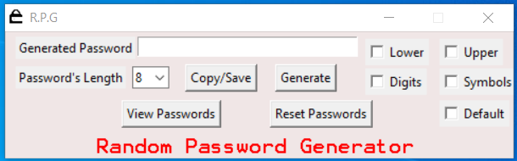

3.2 Error Window

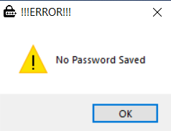

3.3 Generating Password

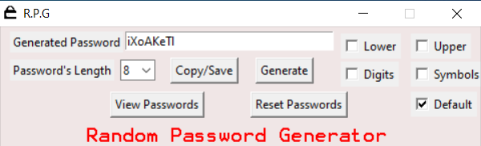

3.4 Text File Containing Passwords

